**By: Leona Lee, Adel Fares, Abdul Alawa, Alan Wei, Randy Cade**

**Submitted to: Catherine Roy-Heaton**

**FNCE 4409 - 001**

|  |
| --- |
| Current Stock Price: **$1.26**/share  Price-to-Sales Model: **$1.11**/share  Multi-stage DDM: **$0.93**/share  Forecasted Price: **$1.11 * 70% = $0.777**  **$0.93 * 30% = $0.279**  **$1.056** |

# Overview

## Summary

This research paper is served to assess the company, Bombardier, as a financial security. The paper will look into Bombardier’s industry and competitive analysis, its historical performances, risks that could affect its future performances, and numerous valuation models to determine its worth in the financial market.

## Valuation Models

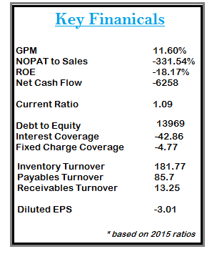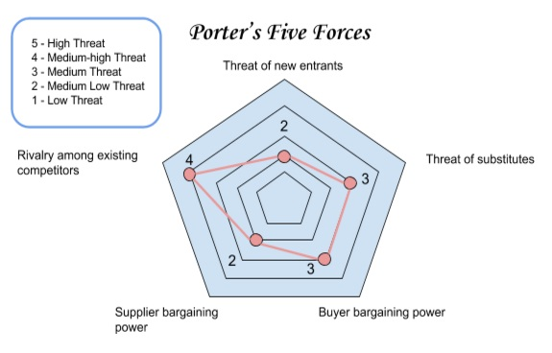 The valuation models that were used for this project are the Price-to-Sales Model, and the multi-stage Dividend Discount Model. Due to Bombardier’s severely underperforming profits being posted over the last 5 years, our options are limited to only the 2 valuation models mentioned above. The reason being that Bombardier is currently operating on a negative cash flow, and therefore all other main standards of valuation (such as FCFF, RI, and Justified P/E) become unusable. The target price was determined by using a weighted average between the Price-to-Sales Model and the multi-stage DDM of 70% and 30%, respectively.

## Our Recommendation

After analyzing Bombardier’s position in the financial market, it would be not be worthwhile to consider Bombardier as a financial investment. In 2011, Bombardier was trading around $7/share, but it began to rapidly decline and reached an all-time low in August 2015 when it hit $1.11/share. Today, Bombardier is trading at $1.26/share and still remains very risky for investors to buy into this company.

# Company Description:

During the winter of 1942, Joseph-Armand Bombardier founded Bombardier as L’Auto-Neige Bombardier Limitée to help the rural residence of Quebec to travel across the snow-covered roads (History of Bombardier, n.d.). Bombardier, a Canadian multinational aerospace and transportation company, is known as one of the world’s leading manufacturer in trains and airplanes, and it is evident that they are quite successful as their most recent fiscal year end recorded their revenues at $20.1 billion (History of Bombardier, n.d.). Bombardier’s success suggests that the current members on the Board of Directors are fit to lead the company.

Alain Bellemare, Bombardier’s current President and CEO as of February 13, 2015, has demonstrated that he is qualified for the position as he holds an MBA, a bachelor’s degree in mechanical engineering, and specialized in aeronautical engineering (Alain Bellemare, n.d.). Even though the President of Commercial Aircraft, Fred Cromer, has more than 23 years worth of experience in aviation, a bachelor’s degree in Economics and an MBA in Finance, he has become the center of attention since Bombardier had faced setbacks with the launch of their CSeries aircraft (Fred Cromer, n.d.).

The delays with the introduction of the CS100 aircraft gave Boeing and Airbus an advantage as they have sold about 6,000 more efficient and quieter jets, whereas Bombardier has only pre-sold about 250 (Pittis, 2015). In addition to the CSeries delays, Bombardier announced a loss of $4.9 billion dollars in their third quarterly report despite their prosperous fiscal year in 2014, and thus prompting the Quebec government to step in by investing $1 billion dollars into Bombardier’s CSeries program (Pittis, 2015). While the Quebec government faces backlashes from its residence, they had done so because there are about 17,000-18,000 Bombardier jobs in Quebec and about 40,000 tier-two suppliers jobs (Pittis, 2015).

# Industry Analysis & Competitive Analysis

## The Industry As A Whole

The industry as measured (see Appendix 1) showed immense growth prior to 2015; however, as of the year-end in 2014, the market showed stagnation with Bombardier falling at a rapid pace compared to its larger rivals (Bloomberg L.P., 2015a).

## The Performance of the Industry Compared to GDP.

When comparing the GDP (see Appendix 2) of the top 3 economic zones (U.S, Europe, China) in relation to the industry backlog of aircraft, there seems to be no relation between GDP growth, and the extent to which the industry experiences new orders (Bloomberg L.P., 2015a).

## Industry & Company Financial Ratios

The aerospace industry is a link in the supply chain for cargo and passenger jets. With this in mind, we can look at how well the airline industry is doing, and if there is a rising trend in demand for flights then it is likely that demand for production of new aircraft will follow. Clayton and Hilz stated that the overall trends in the passenger airline industry for revenue base has doubled but turning a profit is still extremely difficult, while others in the supply chain (airports, engine manufacturers, hull producers) will make a profit (2015). The demand for flights is expected to grow, so an increase in demand for planes will need to be filled by manufacturers like Bombardier, Boeing, and Airbus and therefore, driving up their profits. Companies with lower debt will be in a better position to take advantage of the increase in demand from the growth in the airline industry.

The debt/asset ratio for Bombardier is 27.8%, which is remarkably high compared to Boeing and Airbus at 9.1% and 7.6%, respectively (see Appendix 3). Having such a high ratio in comparison to its larger competitors can be a major issue as Bombardier’s direct competitors, suppliers or clients could turn on them and thus further reducing their profit margins. We could see Bombardier’s clients taking advantage of the higher debt ratio by asking for a steeper discount on contracts, subsequently, Bombardier would be more willing to accept these terms since profitable margins are hard to come by in the airline industry.

## Suppliers/Clients

As Bombardier has become more strapped for cash, they have been putting pressure on any outstanding accounts receivable increasing their receivables turnover ratio from a low of 8.53 in 2007 to a high of 14.37 in 2014 (see Appendix 3). Bombardier became stricter when collecting their debts outstanding to clients to insure they have the required funds to cover their day-to-day expense and to cover the costs of having to pay their suppliers more rapidly. In addition, most of Bombardier’s clients for the new CSeries are small airliners and startups with a few of the bigger firms standing by waiting for the airline to finish being tested (Tomesco, 2014).

When looking at Bombardier's suppliers, one of the first things that needs to be addressed is how they are paying them. Bombardier’s payables period has drastically shifted being more than halved from a high of 202 days in 2006 down to a low of 62 days in 2014 (see Appendix 3). This indicates that their suppliers have tightened the reins on any debt they will lend to Bombardier applying more pressure to an already overwhelmed company. None of Bombardier’s supply lines seem to be in any threat from a company going bankrupt in the near future or having any of them cut Bombardier off. However, all of these companies have become cautious as to any outstanding debt they extend to Bombardier.

## Porter’s Five Forces

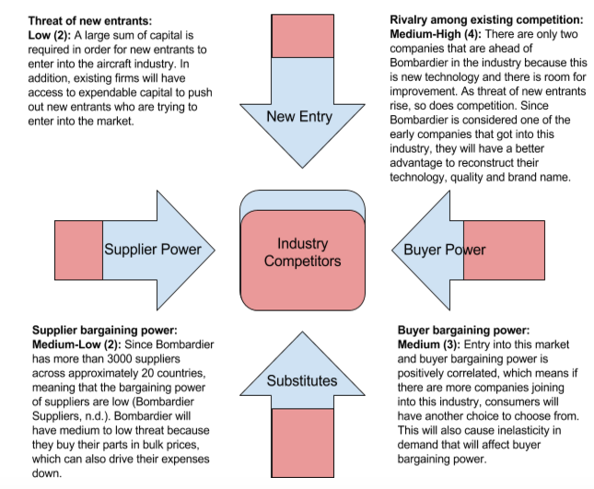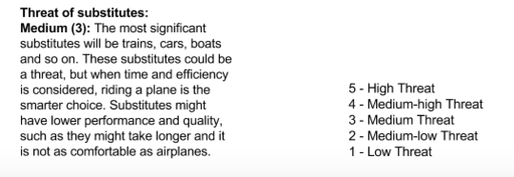

## SWOT Analysis

STRENGTHS: Bombardier has the advantage of being first of few companies that manufactures not only aircraft, but trains and other forms of transportation as well. This gives Bombardier a recognized brand name in the aerospace industry, while also having a broader scope of engines and materials development (Bombardier, 2003). Bombardier became even more recognized and respected after the acquisition of Learjet in 1990 (Bombardier, 2003). When Bombardier acquired Learjet for their advanced technology, they also assumed the goodwill and respect associated with the luxurious Learjet brand. Additionally, Bombardier is the third largest aerospace company in the world after Airbus and Boeing.

WEAKNESSES: The company could pay off most of its debt if they were to sell 100% in an IPO or if they spun off a section of the company, but it can be difficult to bring in new leadership and management because the current family has a controlling vote, which has resulted in Bombardier sinking further into debt (Bhaskara, 2015). The Canadian government will often block deals for foreign companies to take over Canadian firms that are deemed too valuable to the nation, thus making it more difficult for Bombardier to make deals (Bhaskara, 2015). The Quebec government also has offered financial aid via tax breaks that could add up to $40 million dollars (Bhaskara, 2015).

OPPORTUNITIES: According to Bombardier’s financial reports, they have invested a lot of capital into R&D, which may suggests an innovative plan which would allow the company to make aircrafts at a more efficiently and at a lower price (Bombardier, 2015b). Also with growing demand for aircraft, there is opportunity for the company to further innovate their technologies.

THREATS: Bombardier’s CSeries has not been able to acquire all the contracts/orders that they originally anticipated, and have even discussed with Airbus to bankroll them until their CSeries gets into production with Airbus taking a controlling share of the line (Davidson, 2015). Another major issue for the line is the fact that oil prices have dropped significantly, as one of the key selling points of the planes were that they should be 20% more efficient than their competitors. Lastly, the CSeries planes have been placed in an awkward size range, as it seems too small for Air Canada and too big for Jazz and WestJet (Davidson, 2015).

## Risks

RISK WITHIN THE COMPANY: Bombardier has already lost $4.9 billion USD in the third quarter, and with that, one of their biggest risks becomes funding their CSeries and other programs (Argitis and Tomesco, 2015). Even though Quebec recently helped the company by bailing the company out with $1 billion USD, they are still trying to convince the federal authorities to match the Quebec’s commitment (Argitis and Tomesco, 2015).

RISK WITHIN THE GOVERNMENT: The original cost of developing the CSeries was pegged at $3.4 billion USD. If the newly elected Liberal government won’t lend Bombardier the money, then the company’s cash flow will financially be affected (Keenan, 2015). Bombardier’s schedule for the CSeries program is delayed mostly because of the engine failure in 2014 that required an extra $2 billion USD in 2016 in order to deliver the plane to the market (Keenan, 2015).

ECONOMIC RISK: INFLATION: Inflation occurs when the general level of prices for goods and services is rising while the purchasing power of currency falls (InflationData, 2013). Aside from that, it can leads to uncertainty in the financial market and thus, making planning of production difficult. Higher inflation rates will result in employees demanding higher wages. With Bombardier’s economic standing, there is a lot of pressure on them since their costs have now increased and will then raise prices to maintain their profit margin, which is difficult because of their delayed CSeries project (InflationData, 2013).

ECONOMIC RISK (EMPLOYMENT): If the CSeries project did fail, one major problem would be laid offs and unemployment (Remiorz, 2015). Quebec alone employs about 18,000 workers and the high-paying jobs that would disappear (2015). If Bombardier has a reputation for failing their major projects and laying people off, then people would have second guesses if they would like to work for them and how hard are they willing to try (Remiorz, 2015).

ECONOMIC RISK (OIL/GAS): Remiorz mentions that Canada is indeed in a recession and the government is sinking further into debt (2015). This recession is caused by many factors, such as oil and gas, which can be a huge risk for Bombardier. There is a direct correlation between the cost of gas to the price of transporting. A drop in prices means lower transport cost and can benefit those in the manufacturing sector since many industrial chemicals are refined in oil (Remiorz, 2015). Contrastingly, businesses and consumers are hit with higher transporting and manufacturing cost when there is an increase in oil price (Remiorz, 2015).

# https://lh4.googleusercontent.com/Jx4ZJlUUTXvNgUqNT6wzGAExwxcwaGYBF5fJ-iklJV-W6Xn-cpp4L-huEeN4Z_eb2PDP0s_vZ5uHFbiPsImRdgN6UlAs84rHFjs7Leqk0kJqxL8kRw_HRBdy9Fmz2x9dwLmnz0YWHistorical Performance

*(Yahoo Finance, 2015)*

## Historical Highlights

* October of 2015, Bombardier requested a sum of $1B from Quebec’s government.
* September 30, 2015, Bombardier announced financial losses in the third quarter of $4.6B in 2015, compared to earnings of $171M in 2014.
* January 15, 2015, Bombardier announced that the company will pause its Learjet-85 business aircraft program
* January 2014, Republic Airways CEO, which is Bombardier's largest client for the CSeries jets had stated a sense of concern in regards to slow sales and production of CSeries jets
* March 1, 2012, Bombardier announced a drop in net income of $295M, compared to 2011 due to a shift in its year-end to Dec. 31, from Jan. 31.
* September 13, 2011, Bombardier layoffs 1,400 jobs due to the Chinese economy slowdown and the drop in private jet orders. *(Google News, 2015)*

On January 15, 2015, Bombardier announced that the company will pause its Learjet-85 business aircraft program due to weak market demand for these planes. According to Bombardier’s website, the company shifting their focus and resources towards the CSeries and Global 7000/8000 programs, as there is greater market potential (2015a). Due to the delay, a pre-tax special charge of an estimated $1.4 billion USD later showed up in the fourth quarter of 2014, prompting investors to take a step back. The investors lost confidence upon hearing the news release, leading Bombardier’s stock drop from $4.04 to $2.71 in a very short time. In October 2015, Bombardier requested more funding from the Canadian government to keep the CSeries passenger jet program alive. The Quebec government had plagued $1 billion USD to help the company once the newly elected Liberal government takes over from the Conservatives. During the same period of the news release to the public, Bombardier’s stock went up 24% (Blatchford, 2015).

## Dividends

According to Bombardier financial report from 2014, dividends paid out to shareholders has been constant throughout the past 5 years (2015b). The constant payout yield of 2.4% on class A and B shares are partially due to the lack of growth within the company, which could explain Bombardier’s stock dropping by 50% this year alone (Yahoo Finance, 2015). In 2016, dividends per share will be reduced from $0.10/share to $0.02/share, possibly driving Bombardier’s stock prices further lower (Bombardier, 2015b).

Bombardier has delayed the delivery of their CSeries jets to airliners by two years. If Bombardier continues to push back the original scheduled date, customers and investors are more likely to shy away (Bombardier, 2015a). Furthermore, Bombardier’s stock prices are still falling from an all-time high, which was 5 years ago, indicating the possibility of the price continuing to fall if the economic slowdown continues in 2016.

## Bombardier's Stock vs. TSX Index

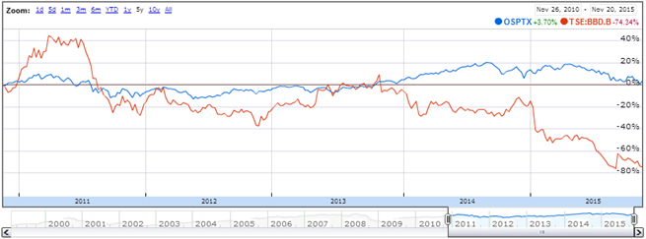

*(Google Finance, 2015)*

Over the past five years, Bombardier’s stock price compared to the TSX index has regressed to -80%. After the financial crisis, the volatility of Bombardier’s price stabilized, however, the price behavior of the stock began to fall opposite of the TSX index.

The systematic risk within the aerospace market in which Bombardier competes is fairly low. Although, recent oil prices have may have temporarily hurt sales of commercial airplanes globally, the entire market continues to have great volatility or movement. Volatility is a key indicator commonly used by analytic investors in order measure risk and returns on a stock. In Canada, Bombardier still has a chance of coming back and succeeding as interest rates remain at an all-time low and inflation has been steady over the past few years.

## Ratios Compared to Industry

Bombardier’s profitability, liquidity, and solvency ratios indicate poor company performance compared to industry averages over the past five years. Gross profit margin ratio has been fairly low and unstable compared to industry averages, indicating unstable financial health of the company. The current ratio follows suit compared to industry averages, which can be directly linked to Bombardiers poor liquidity. On the other hand, Bombardier’s high debt to equity ratio points to good use of leverage over suppliers, lenders and creditors, versus what the shareholders have committed into company. Lastly, compared to the industry average, Bombardier’s low inventory turnover ratio implies poor sales of their jets and possible excess inventory. Also, the current ratio being low compared to industry averages, can directly be linked to poor liquidity.

# Valuation

FCFF and FCFE cannot be used as Bombardier is currently operating at a net loss and these models will produce a negative valuation. At this time, these models cannot be relied on to produce an accurate valuation with the company in its current state. In addition, EBIT and EBITDA cannot be used since the only thing that was positive on the company’s financials was their revenue with everything following being negative. The next model attempted was the residual income model, which also resulted in a negative valuation and cannot be used since the company has no income after basic expenses. With so many models having been stricken from how to find the value of the company, the only ones available to use are the multi-stage DDM, and Price-to-Sales, with the ROE formula to further explain why the company is performing so poorly.

## Price/Sales

P0 / S0 = P1 / S1 → P0 / S0 * (S1 + Average sales of previous 3 quarters)

P1 = (1.26 / 20111) * (13155 + 4522) = **$1.11/share**

Using the Price-to-Sales model for valuation, we find that in Bombardier’s current state, their current price is overvalued by $0.15. While this amount may be fairly negligible, it still raises concern, as predicted performance is likely to be a worst-case scenario, and is still expected to decline even with Quebec’s recent injection of $1 billion dollars.

## DuPont Decomposition (Using most recent 9 months)[1]

ROE = (NI / Pretax Income) * (Pretax Income / EBIT) * (EBIT / Sales) * (Sales / Assets) * (Assets / Equity)

ROE = (-4633 / -4455) * (-4455 / -4181) * (-4181 / 13155) * (13155 / 23864) * (23863 / -3660) = **127%**

Splitting the ROE into its 5 components, we can further our understanding as to why the company is turning such a high value:

TAX BURDEN: With net income being in the red over the last 2 years, Bombardier was able to use their losses as a tax deduction; however, since both their net income and their pretax income were listed as they were (as negatives), it shows Bombardier to be paying much more than its competitors. This is merely an equation issue, and should be noted that Bombardier is able to use their losses as a deduction, allowing the company to pay much less than required if they had turned an annual profit.

INTEREST BURDEN: As before, with Bombardier operating at a loss this year, both its pretax income and their EBIT are listed as negative values. While mathematically, this shows as a positive ratio, the high borrowing costs, coupled with negative operating costs, shows that Bombardier is not even able to cover the interest costs incurred on their debt, with profits from operations.

OPERATING PROFIT: Evaluating the company’s core business operations on the final ROE, shows that Bombardier is operating at a loss per unit of sale generated. This is most likely due to the cost of “special items” incurred (see Appendix 4) being greater than the company’s earning at that given time.

ASSET TURNOVER: With Bombardier’s asset turnover sitting around the .5X mark, it further strengthens the understanding of why the company is performing so poorly. Being unable to efficiently drive sales using their assets, Bombardier falls well under the average of its competition, further affecting their ROE in a negative manner.

LEVERAGE RATIO: Carrying the greatest weight on Bombardier’s ROE, this ratio shows how heavily leveraged the company’s debt is up to this point. Due to the value of the company’s assets being less than the outstanding value of debt, the ratio negatively impacts overall ROE in a significant way.

## Multi-Stage DDM

k = 9.8% (Bloomberg L.P., 2015). g = Canada’s current GDP growth rate @ 1% (TradingEconomicS, 2015)

P0 = (D1 / (1 + k)) + (D2 / (1+k)2) + (D3 / (1+k)3) + ((D4 / (ke - g)) / (1 + k)3)

P0 = (0.02 / (1 + 0.098)) + (0.02 / (1 + 0.098)2) + (0.05 / (1 + 0.098)3) + ((0.10 / (0.098 - .01)) / (1 + 0.098)3) = **$0.93/share**

Consistent Price/Sales Model, the multi-stage DDM (given a best case scenario, where after dropping their dividends to $0.02/share for 2016 from $0.10/share, the company will increase their dividends back to $0.10/share over the course of 4 years) shows that Bombardier is overvalued by $0.33 cents. As stated above, this is in line with the company’s failing performance, further strengthening our valuation of Bombardier.

## Weighting

PRICE-TO-SALES (70%):Giving a more accurate valuation compared to the multistage, Price-to-Sales carries more of the weight, as the ratio is relative to the performance of the company at this point in time.

MULTI-STAGE DDM (30%):As the multi-stage was calculated using a best-case scenario, it’s weighed far less than the Price-to-Sales model. Being based on an assumption, it is only rational to weigh it in such a way, as the ratio is a presumption, which may not play out to the extent given.

# Appendix 1: Aircraft Backlog

Aircraft Backlog: White; Blue: Bombardier; Green: Airbus; Purple: Boeing

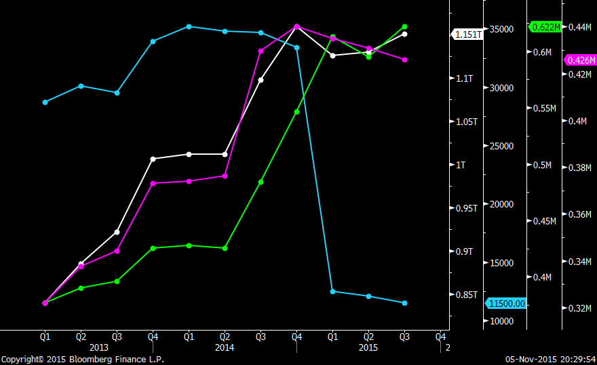

Aircraft backlog: White; Red: Bombardier; Yellow: Airbus; Orange: Boeing

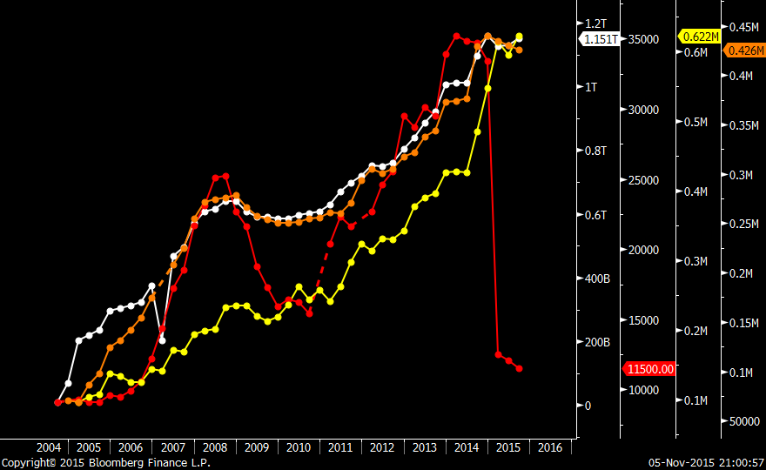

# Appendix 2: GDP

GDP of China: Purple; Euro Zone: Pink; and USA: Green with Aircraft backlog: Grey

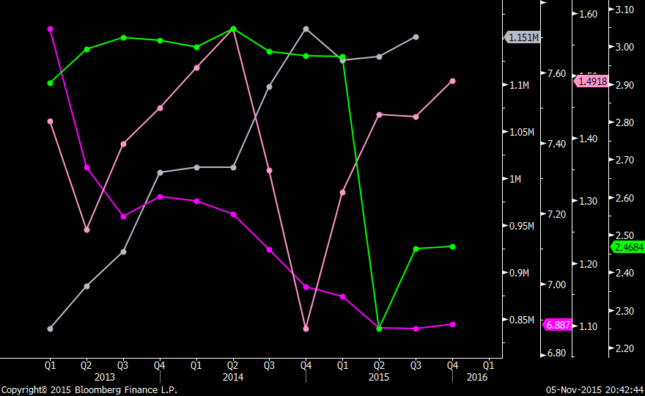

Based off of the above graph GDP and the backlog do not appear to be linked.

# Appendix 3: Ratio Analysis

|  |  |  |  |  |  |  |  |  |
| --- | --- | --- | --- | --- | --- | --- | --- | --- |
|  |  | **2011** | **2012** | **2013** | **2014** | **2015 Current** | **2016 Est.** | **Industry Avg.**  **Adj. Over 5 Yrs.** |
| **Profitability Ratios** |  |  |  |  |  |  |  |  |
| **Gross Profit Margin** | Bombardier | 15.82% | 14.38% | 13.73% | 12.81% | 11.60% | 11.45% |  |
| Industry avg. |  |  |  |  |  |  | 21.33% |
| **NOPAT to Sales** | Bombardier | 5.13% | 3.48% | 4.69% | -4.93% | -331.54% |  |  |
| Industry avg. |  |  |  |  |  |  | 5.73% |
| **Fiscal Year ROE** | Bombardier | 44.54% | 74.54% | 36.15% | Footnote 1[2] | -127% | 11.70% |  |
| Industry avg. |  |  |  |  |  |  | 13.45% |
| **Net Cash Flow**  **from Op. (mm)** | Bombardier | 837 | 460 | 564 | -1260 | -6258 |  |  |
| Airbus | 4289 | 3840 | 1829 | 2560 | 3146 |  |  |
| Boeing | 4023 | 7508 | 8179 | 8858 | 6244 |  |  |
| **Liquidity Ratios** |  |  |  |  |  |  |  |  |
| **Current Ratio** | Bombardier | 1.11 | 1.06 | 1.06 | 0.98 | 1.09 |  |  |
| Industry avg. |  |  |  |  |  |  | 1.74 |
| **Solvency Ratios** |  |  |  |  |  |  |  |  |
| **Debt to Equity** | Bombardier | 707.6% | 426.41% | 285.34% | 13969.09% |  |  |  |
| Industry avg. |  |  |  |  |  |  | 145.28% |
| **Interest Coverage** | Bombardier |  | 9.12 | 10.49 | -15.3 | -42.86 |  |  |
| Industry avg. |  |  |  |  |  |  |  |
| **Fixed Charge Coverage** | Bombardier | 3.29 | 7.01 | 0.56 |  | -4.77 |  |  |
| Industry avg. |  |  |  |  |  |  |  |
| **Asset Utilization Ratios** |  |  |  |  |  |  |  |  |
| **Inventory Turnover[3]** | Bombardier | 2.44 | 1.88 | 1.99 | 2.16 | 2.01 |  |  |
| Industry avg. |  |  |  |  |  |  | 4.47 |
| **Inventory Turnover[4]** | Bombardier | 129.68 | 197.71 | 186.05 | 168.66 | 181.77 |  |  |
| **Previous 5 Yr. Avg.** | 108.09 |  |  |  |  |  |  |  |
| **Payables Turnover** | Bombardier | - | 90.89 | 75.9 | 62.41 | 85.7 |  |  |
| **Previous 5 Yr. Avg.** | 174.0525 |  |  |  |  |  |  |  |
| **Receivables Turnover** | Bombardier | 9.04 | 11 | 12.47 | 14.37 | 13.25 |  |  |
| **Previous 5 Yr. Avg.** | 9.318 |  |  |  |  |  |  |  |
| **Valuation Measures** |  |  |  |  |  |  |  |  |
| **Diluted EPS** | Bombardier | 0.47 | 0.25 | 0.31 | -0.74 | -3.01 |  |  |
| Industry avg. |  |  |  |  |  |  | 1.94 |

Source: Bloomberg, Morningstar & Team Valuation

# Appendix 4: Pro-Forma Financial Statements[5]

|  |  |  |  |  |  |  |  |  |  |  |
| --- | --- | --- | --- | --- | --- | --- | --- | --- | --- | --- |
| Bombardier Inc (BBD/B CN) – Adjusted Annual Income Statement | | | | | | | | | | |
|  |  |  |  |  |  |  |  | Bloomberg |  |  |
| In Millions of USD except Per Share | FY 2008 | FY 2009 | FY 2010 | FY 2011 | FY 2012 | FY 2013 | FY 2014 | FY 2015 Est | FY 2016 Est | FY 2017 Est |
| 12 Months Ending | 01/31/2008 | 01/31/2009 | 01/31/2010 | 12/31/2011 | 12/31/2012 | 12/31/2013 | 12/31/2014 | 12/31/2014 | 12/31/2016 | 12/31/2017 |
| Revenue | 17,506.00 | 19,721.00 | 19,366.00 | 18,347.00 | 16,414.00 | 18,151.00 | 20,111.00 | 18,705.60 | 18,286.56 | 17,876.90 |
| + Sales & Services Revenue | -- | 17,896.00 | 17,506.00 | 18,347.00 | 16,414.00 | 18,151.00 | 20,111.00 |  |  |  |
| + Other Revenue | -- | 1,825.00 | 1,860.00 | -- | -- | -- | -- |  |  |  |
| - Cost of Revenue | 15,119.00 | 16,049.00 | 16,202.00 | 15,444.00 | 14,053.00 | 15,658.00 | 17,534.00 | 15,890.45 | 15,534.47 | 15,186.47 |
| + Cost of Goods & Services | -- | 16,049.00 | 16,202.00 | 15,444.00 | 14,053.00 | 15,658.00 | 17,534.00 |  |  |  |
| Gross Profit | 2,387.00 | 3,672.00 | 3,164.00 | 2,903.00 | 2,361.00 | 2,493.00 | 2,577.00 | 2,127.10 | 2,752.09 | 2,690.43 |
| + Other Operating Income | 62 | 23 | 0 | 0 | 0.00 | 0 | 0 |  |  |  |
| - Operating Expenses | 1,547.00 | 2,269.00 | 2,005.00 | 1,669.00 | 1,586.00 | 1,625.00 | 1,653.00 | 1,556.52 | 1,465.67 | 1,380.12 |
| + Selling, General & Admin | 1,408.00 | 1,558.00 | 1,453.00 | 1,439.00 | 1,442.00 | 1,417.00 | 1,358.00 | 1,321.63 | 1,286.23 | 1,251.78 |
| + Research & Development | -- | 171 | 141 | 271 | 299 | 293 | 347 | 417.38 | 502.03 | 603.85 |
| + Depreciation & Amortization | -- | 555 | 498 | -- | -- | -- | -- |  |  |  |
| + Other Operating Expense | -- | -15 | -87 | -41 | -155 | -85 | -52 | (116.60) | (261.47) | (586.32) |
| Operating Income (Loss) | 902 | 1,426.00 | 1,159.00 | 1,234.00 | 775 | 868 | 924 | 674.50 | 492.37 | 359.42 |
| - Non-Operating (Income) Loss | -- | 138 | 183 | 177 | 147 | 164 | 139 | 141.42 | 143.88 | 146.38 |
| + Interest Expense, Net | 301 | -- | -- | -- | -- | -- | -- |  |  |  |
| + Interest Expense | 526 | 307 | 223 | -- | 73 | 88 | 37 |  |  |  |
| - Interest Income | 225 | -- | -- | -- | -- | -- | -- |  |  |  |
| + Foreign Exch (Gain) Loss | -- | -75 | -6 | 0 | 0 | 0 | 0 |  |  |  |
| + (Income) Loss from Affiliates | -- | 0 | 0 | 0 | -- | -- | -89 |  |  |  |
| + Other Non-Op (Income) Loss | -- | -94 | -34 | 177.00 | 74.00 | 76 | 191 | (33.84) | 6.00 | (1.06) |
| Pretax Income (Loss), Adjusted | 439 | 1,288.00 | 976 | 1,057.00 | 628 | 704 | 785 | 383.00 | 186.86 | 91.17 |
| - Abnormal Losses (Gains) | -18 | 15 | 61 | 17 | 92 | -67 | 1,525.00 |  | 0.00 | 0.00 |
| + Disposal of Assets | -- | -26 | -19 | -3.00 | -6.00 | -- | -3 |  |  |  |
| + Early Extinguishment of Debt | -- | -- | -- | -15 | -- | -- | 43 |  |  |  |
| + Asset Write-Down | -- | -- | -- | 8 | 9 | -- | 1,357.00 |  |  |  |
| + Sale of Business | -- | 23 | -20 | -- | -- | -23 | -- |  |  |  |
| + Legal Settlement | -- | -28 | -- | -- | -40 | -42 | -18 |  |  |  |
| + Restructuring Charges | -- | 46 | 100 | 7 | 110 | -2 | 146 | (1,607.75) | 17,704.55 | (194,962.49) |
| + Other Abnormal Items | -- | -- | -- | 20 | 19 | -- | -- |  |  |  |
| Pretax Income (Loss), GAAP | 439 | 1,273.00 | 915 | 1,040.00 | 536 | 771 | -740 | (4,410.00) | (26,281.22) | (156,621.84) |
| - Income Tax Expense (Benefit) | 122 | 265 | 208 | 203 | 66 | 199 | 506 | 773.56 | 1,182.59 | 1,807.91 |
| + Current Income Tax (Benefit) | -- | 196 | 217 | 137.00 | 107.00 | 125 | 152 | 149.07 | 146.20 | 143.39 |
| + Deferred Income Tax (Benefit) | -- | 69 | -9 | 66 | -41 | 74 | 354 | (361.51) | 369.18 | (377.01) |
| + Tax Allowance/Credit | -- | 0 | 0 | 0 | 0 | 0 | 0 |  |  |  |
| Income (Loss) from Cont Ops | 317 | 1,008.00 | 707 | 837 | 470 | 572 | -1,246.00 | (4,623.10) | (17,153.33) | (63,644.92) |
| - Net Extraordinary Losses (Gains) | 0 | 0 | 0 | 0.00 | 0.00 | 0 | 0 |  |  |  |
| + Discontinued Operations | -- | 0 | 0 | 0 | 0 | 0 | 0 |  |  |  |
| Income (Loss) Incl. MI | 317 | 1,008.00 | 707 | 837 | 470 | 572 | -1,246.00 | (370.18) | (109.98) | (32.68) |
| - Minority Interest | 0 | 0 | 9 | 0 | 10 | 8 | 14 |  |  |  |
| Net Income, GAAP | 317 | 1,008.00 | 698 | 837.00 | 460.00 | 564 | -1,260.00 | (4,625.70) | (16,981.83) | (62,343.52) |
| - Preferred Dividends | 30 | 27 | 21 | 25 | 29 | 32 | 27 | 27.41 | 27.82 | 28.24 |
| - Other Adjustments | 0 | 0 | 0 | 0 | 0 | 0 | 0 |  |  |  |
| Net Income Avail to Common, GAAP | 287 | 981 | 677 | 812 | 431.00 | 532 | -1,287.00 | (4,649.10) | (16,794.20) | (60,666.59) |
|  |  |  |  |  |  |  |  |  |  |  |
| Net Income Avail to Common, Adj | 287 | 991.1 | 719.1 | 824.2 | 499.1 | 482.4 | -166.1 | 238.80 | (343.32) | 493.59 |
| Net Abnormal Losses (Gains) | -11.70 | 10.10 | 42.10 | 12.20 | 68.10 | -49.60 | 1,120.90 | (2,978.69) | 7,915.62 | (21,035.05) |
| Net Extraordinary Losses (Gains) | 0 | 0 | 0 | 0 | 0 | 0 | 0 |  |  |  |
|  |  |  |  |  |  |  |  |  |  |  |
| Basic Weighted Avg Shares | 1,733.20 | 1,730.50 | 1,729.80 | 1,724.90 | 1,730.80 | 1,738.90 | 1,741.70 | 1,743.95 | 1,746.21 | 1,748.47 |
| Basic EPS from Cont Ops | 0.17 | 0.57 | 0.39 | 0.47 | 0.25 | 0.31 | -0.74 | (2.08) | (5.85) | (16.43) |
| Basic EPS from Cont Ops, Adjusted | 0.16 | 0.57 | 0.42 | 0.48 | 0.29 | 0.28 | -0.1 | (0.06) | (0.04) | (0.02) |
|  |  |  |  |  |  |  |  |  |  |  |
| Diluted Weighted Avg Shares | 1,756.40 | 1,754.40 | 1,755.00 | 1,743.90 | 1,737.80 | 1,741.10 | 1,742.50 | 1,740.14 | 1,737.78 | 1,735.42 |
| Diluted EPS from Cont Ops | 0.16 | 0.56 | 0.39 | 0.47 | 0.25 | 0.31 | -0.74 | (0.19) | (0.05) | (0.01) |
| Diluted EPS from Cont Ops, Adjusted | 0.15 | 0.57 | 0.41 | 0.48 | 0.29 | 0.28 | -0.1 | 0.12 | (0.14) | 0.17 |
|  |  |  |  |  |  |  |  |  |  |  |
| Reference Items |  |  |  |  |  |  |  |  |  |  |
| EBITDA | -- | 1,981.00 | 1,657.00 | 1,567.00 | 1,139.00 | 1,259.00 | 1,341.00 | 1,089.90 | 885.82 | 719.95 |
| EBITDA Margin (T12M) | -- | 10.05 | 8.56 | 8.54 | 6.94 | 6.94 | 6.67 | 24.98 | 93.55 | 350.37 |
| EBITA | -- | 1,801.00 | 1,489.00 | -- | -- | -- | -- |  |  |  |
| EBIT | 902 | 1,426.00 | 1,159.00 | 1,234.00 | 775.00 | 868 | 924 | 674.50 | 492.37 | 359.42 |
| Gross Margin | 13.64 | 18.62 | 16.34 | 15.82 | 14.38 | 13.73 | 12.81 | 45.70 | 163.04 | 581.63 |
| Operating Margin | 5.15 | 7.23 | 5.98 | 6.73 | 4.72 | 4.78 | 4.59 | 14.55 | 46.12 | 146.21 |
| Profit Margin | 1.81 | 5.16 | 3.82 | 4.63 | 3.22 | 2.83 | -0.69 | 5.54 | (44.48) | 357.13 |
| Dividends per Share | 0 | 0.08 | 0.09 | 0.1 | 0.1 | 0.1 | 0.1 | 0.10 | 0.11 | 0.11 |
| Total Cash Common Dividends | 0 | 120 | 157 | 179 | 177 | 173 | 160 | 170.87 | 182.47 | 194.86 |
| Rental Expense | 125 | 116 | 134 | 123 | -- | 174 | 175 |  |  |  |

Source: Bloomberg & Team Valuation

|  |  |  |  |  |  |  |  |  |  |  |
| --- | --- | --- | --- | --- | --- | --- | --- | --- | --- | --- |
| Bombardier Inc (BBD/B CN) – Adjusted Quarterly Income Statement | | | | | | | | | | |
| In Millions of USD except Per Share | Q4 2013 | Q1 2014 | Q2 2014 | Q3 2014 | Q4 2014 | Q1 2015 | Q2 2015 | Q3 2015 | Q4 2015 Est | Q1 2016 Est |
| 3 Months Ending | 12/31/2013 | 03/31/2014 | 06/30/2014 | 09/30/2014 | 12/31/2014 | 03/31/2015 | 06/30/2015 | 09/30/2015 | 12/31/2015 | 03/31/2016 |
| Revenue | 5,324.00 | 4,354.00 | 4,891.00 | 4,906.00 | 5,960.00 | 4,397.00 | 4,620.00 | 4,138.00 | 5,550.60 | 3,978.50 |
| + Sales & Services Revenue | 5,324.00 | 4,354.00 | 4,891.00 | 4,906.00 | 5,960.00 | 4,397.00 | 4,620.00 | 4,138.00 |  |  |
| - Cost of Revenue | 4,698.00 | 3,761.00 | 4,233.00 | 4,226.00 | 5,314.00 | 3,831.00 | 4,031.00 | 3,721.00 |  |  |
| + Cost of Goods & Services | 4,698.00 | 3,761.00 | 4,233.00 | 4,226.00 | 5,314.00 | 3,831.00 | 4,031.00 | 3,721.00 |  |  |
| Gross Profit | 626 | 593 | 658 | 680 | 646.00 | 566 | 589 | 417 | 555.1 | 457.50 |
| + Other Operating Income | 0 | 0 | 0 | 0 | 0 | 26 | 0 | 0 |  |  |
| - Operating Expenses | 467 | 377 | 397 | 386 | 493.00 | 357 | 376 | 334 |  |  |
| + Selling, General & Admin | 351 | 338 | 354 | 315 | 351.00 | 276 | 297 | 284 |  |  |
| + Research & Development | 83 | 76 | 79 | 80 | 112 | 79 | 79 | 78 |  |  |
| + Other Operating Expense | 33 | -37 | -36 | -9 | 30 | 2 | 0 | -28 |  |  |
| Operating Income (Loss) | 159 | 216 | 261 | 294 | 153 | 235 | 213 | 83 | 143.5 | 126.00 |
| - Non-Operating (Income) Loss | 45 | 34 | 6 | 51 | 48 | 63 | 54 | 76 |  |  |
| + Interest Expense, Net | -- | -- | -- | -- | -- | -- | -- | 27 |  |  |
| + Interest Expense | 10 | 11 | 11 | 7 | 8 | 31 | 50 | 37 |  |  |
| - Interest Income | -- | -- | -- | -- | -- | -- | -- | 10 |  |  |
| + (Income) Loss from Affiliates | -- | -- | -- | -- | -25 | -- | -18 | -- |  |  |
| + Other Non-Op (Income) Loss | 35 | 23 | -5 | 44 | 65 | 32 | 22 | 49 |  |  |
| Pretax Income (Loss), Adjusted | 114 | 182 | 255 | 243 | 105 | 172 | 159 | 7 | 45 | 77.1 |
| - Abnormal Losses (Gains) | -26 | 9 | 39 | 123 | 1,354.00 | 29 | 5 | 4,759.00 |  |  |
| + Disposal of Assets | -- | -- | -4 | -- | 1.00 | -3 | 1 | -1.00 |  |  |
| + Early Extinguishment of Debt | -- | -- | 43 | -- | -- | 22 | -- | -- |  |  |
| + Asset Write-Down | -- | -- | -- | -- | 1,357.00 | -- | -- | -- |  |  |
| + Sale of Business | -23 | -- | -- | -- | -- | -- | -- | -- |  |  |
| + Legal Settlement | 1 | -10 | -8 | -- | -- | -- | -- | -- |  |  |
| + Restructuring Charges | -4 | 19 | 8 | 123 | -4 | 10 | 4 | 9 |  |  |
| + Other Abnormal Items | -- | -- | -- | -- | -- | -- | -- | 4,751.00 |  |  |
| Pretax Income (Loss), GAAP | 140 | 173 | 216 | 120.00 | -1,249.00 | 143 | 154 | -4,752.00 | 45 | 77.10 |
| - Income Tax Expense (Benefit) | 43 | 58 | 61 | 46 | 341 | 43 | 29 | 136 |  |  |
| Income (Loss) from Cont Ops | 97 | 115 | 155 | 74 | -1,590.00 | 100 | 125 | -4,888.00 | 39.9 | 49.8 |
| - Net Extraordinary Losses (Gains) | 0 | 0 | 0 | 0 | 0 | 0 | 0 | 0 |  |  |
| + Discontinued Operations | 0 | 0 | 0 | 0 | 0 | 0 | 0 | 0 |  |  |
| Income (Loss) Incl. MI | 97 | 115 | 155 | 74 | -1,590.00 | 100 | 125 | -4,888.00 |  |  |
| - Minority Interest | 2 | 2 | 2 | 6 | -- | 2 | 0 | 3 |  |  |
| Net Income, GAAP | 95 | 113 | 153 | 68 | -1,590.00 | 98 | 125 | -4,891.00 | 42.3 | 22 |
| - Preferred Dividends | -- | 8 | 0 | 8.00 | -- | 7 | 7 | 7.00 |  |  |
| Net Income Avail to Common, GAAP | 95 | 105 | 153 | 60.00 | -1,590.00 | 91 | 118 | -4,898.00 | 39.9 | 49.80 |
|  |  |  |  |  |  |  |  |  |  |  |
| Net Income Avail to Common, Adj | 75.8 | 111.6 | 181.7 | 150.4 | -594.8 | 112.3 | 121.7 | -35.1 | 39.9 | 49.8 |
| Net Abnormal Losses (Gains) | -19.2 | 6.6 | 28.7 | 90.40 | 995.20 | 21.3 | 3.7 | 4,862.90 |  |  |
|  |  |  |  |  |  |  |  |  |  |  |
| Basic Weighted Avg Shares | 1,739.00 | 1,741.70 | 1,741.80 | 1,741.80 | 1,728.30 | 1,762.00 | 2,127.80 | 2,225.60 |  |  |
| Basic EPS from Cont Ops | 0.05 | 0.06 | 0.08 | 0.03 | -0.92 | 0.05 | 0.06 | -2.2 | 0.01 | 0.02 |
| Basic EPS from Cont Ops, Adjusted | 0.04 | 0.06 | 0.10 | 0.09 | -0.34 | 0.06 | 0.06 | -0.02 |  |  |
|  |  |  |  |  |  |  |  |  |  |  |
| Diluted Weighted Avg Shares | 1,741.60 | 1,742.60 | 1,742.60 | 1,742.10 | 1,728.30 | 1,762.00 | 2,127.80 | 2,225.60 |  |  |
| Diluted EPS from Cont Ops | 0.05 | 0.06 | 0.08 | 0.03 | -0.92 | 0.05 | 0.06 | -2.2 |  |  |
| Diluted EPS from Cont Ops, Adjusted | 0.04 | 0.06 | 0.10 | 0.08 | -0.34 | 0.06 | 0.06 | -0.02 | 0.02 | 0.03 |
|  |  |  |  |  |  |  |  |  |  |  |
| Reference Items |  |  |  |  |  |  |  |  |  |  |
| EBITDA | 265 | 309 | 364 | 399 | 269 | 343 | 316 | 187 | 243.9 | 263.8 |
| EBITDA Margin (T12M) | 6.94 | 6.8 | 6.66 | 6.87 | 6.67 | 6.82 | 6.67 | 5.83 | 5.66 | 5.96 |
| EBIT | 159 | 216 | 261 | 294 | 153 | 235 | 213 | 83 | 143.5 | 126 |
| Gross Margin | 11.76 | 13.62 | 13.45 | 13.86 | 10.84 | 12.87 | 12.75 | 10.08 | 10 | 11.5 |
| Operating Margin | 2.99 | 4.96 | 5.34 | 5.99 | 2.57 | 5.34 | 4.61 | 2.01 | 2.59 | 3.17 |
| Profit Margin | 1.42 | 2.75 | 3.71 | 3.23 | -9.98 | 2.71 | 2.79 | -0.68 | 0.72 | 1.25 |
| Dividends per Share | 0.03 | 0.03 | 0.03 | 0.03 | 0.03 | 0 | 0 | 0 | 0 | 0 |
| Total Cash Common Dividends | 43.5 | 48 | 43.5 | 44.2 | 43.2 | 0 | 0 | 0 |  |  |

Source: Bloomberg & Team Valuation

|  |  |  |  |  |  |  |  |  |  |
| --- | --- | --- | --- | --- | --- | --- | --- | --- | --- |
| Bombardier Inc (BBD/B CN) - Standardized Annual Balance Sheet | | | | | | | | | |
| In Millions of USD except Per Share | FY 2008 | FY 2009 | FY 2010 | FY 2011 | FY 2012 | FY 2013 | FY 2014 | FY 2015 | FY 2016 |
| 12 Months Ending | 01/31/2008 | 01/31/2009 | 01/31/2010 | 12/31/2011 | 12/31/2012 | 12/31/2013 | 12/31/2014 | 12/31/2014 | 12/31/2014 |
| **Total Assets** |  |  |  |  |  |  |  |  |  |
| + Cash, Cash Equivalents & STI | 3,602.00 | 3,470.00 | 3,372.00 | 3,372.00 | 2,557.00 | 3,397.00 | 2,489.00 | 2,385.10 | 2,285.53 |
| + Cash & Cash Equivalents | 3,602.00 | 3,470.00 | 3,372.00 | 3,372.00 | 2,557.00 | 3,397.00 | 2,489.00 | 2,385.10 | 2,285.53 |
| + ST Investments | 0.00 | 0.00 | 0.00 | 0.00 | 0.00 | 0.00 | 0.00 | 0.00 | 0.00 |
| + Accounts & Notes Receiv | 2,624.00 | 2,399.00 | 2,370.00 | 1,408.00 | 1,311.00 | 1,492.00 | 1,538.00 | 1,476.43 | 1,417.32 |
| + Accounts Receivable, Net | 1,998.00 | 1,981.00 | 1,897.00 | 1,408.00 | 1,311.00 | 1,492.00 | 1,538.00 | 1,476.43 | 1,417.32 |
| + Notes Receivable, Net | -- | 418.00 | 473.00 | 0.00 | 0.00 | 0.00 | 0.00 | 0.00 | 0.00 |
| + Inventories | 5,092.00 | 5,522.00 | 5,268.00 | 7,398.00 | 7,540.00 | 8,234.00 | 7,970.00 | 8,355.03 | 9,106.64 |
| + Raw Materials | 0.00 | 0.00 | 0.00 | 0.00 | 0.00 | 0.00 | 0.00 | 0.00 | 0.00 |
| + Work In Process | 4,227.00 | 4,045.00 | 4,214.00 | 5,917.00 | 5,718.00 | 6,505.00 | 6,411.00 | 7,097.57 | 7,857.67 |
| + Finished Goods | 865.00 | 1,477.00 | 1,054.00 | 1,481.00 | 1,429.00 | 1,328.00 | 1,266.00 | 1,257.46 | 1,248.97 |
| + Other Inventory | 0.00 | 0.00 | 0.00 | 0.00 | 393.00 | 401.00 | 293.00 | 0.00 | 0.00 |
| + Other ST Assets | 1,295.00 | 777.00 | 682.00 | 1,085.00 | 1,123.00 | 1,518.00 | 1,122.00 | 1,330.41 | 1,577.54 |
| + Derivative & Hedging Assets | -- | 179.00 | 98.00 | 44.00 | 0.00 | 0.00 | 0.00 | 0.00 | 0.00 |
| + Misc ST Assets | -- | 598.00 | 584.00 | 1,041.00 | 1,123.00 | 1,518.00 | 1,122.00 | 1,330.41 | 1,577.54 |
| **Total Current Assets** | **12,613.00** | **12,168.00** | **11,692.00** | **13,263.00** | **12,531.00** | **14,641.00** | **13,119.00** | **13,546.96** | **14,387.03** |
| + Property, Plant & Equip, Net | 1,732.00 | 1,568.00 | 1,643.00 | 1,864.00 | 1,933.00 | 2,066.00 | 2,092.00 | 2,214.60 | 2,343.48 |
| + Property, Plant & Equip | 3,402.00 | 3,133.00 | 3,431.00 | 4,010.00 | 4,190.00 | 4,388.00 | 4,444.00 | 4,771.77 | 5,123.71 |
| - Accumulated Depreciation | 1,670.00 | 1,565.00 | 1,788.00 | 2,146.00 | 2,257.00 | 2,322.00 | 2,352.00 | 2,557.17 | 2,780.24 |
| + LT Investments & Receivables | -- | 0.00 | 0.00 | 0.00 | 0.00 | 0.00 | 0.00 | 0.00 | 0.00 |
| + Other LT Assets | 7,775.00 | 7,570.00 | 7,938.00 | 8,737.00 | 10,711.00 | 12,656.00 | 12,403.00 | 26,035.02 | 32,764.27 |
| + Total Intangible Assets | 3,984.00 | 3,409.00 | 3,943.00 | 5,648.00 | 7,296.00 | 9,173.00 | 9,106.00 | 11,165.41 | 13,690.59 |
| + Goodwill | 2,533.00 | 2,010.00 | 2,247.00 | 2,253.00 | 2,316.00 | 2,381.00 | 2,127.00 | 2,156.75 | 2,186.91 |
| + Other Intangible Assets | 1,451.00 | 1,399.00 | 1,696.00 | 3,395.00 | 4,980.00 | 6,792.00 | 6,979.00 | 9,871.54 | 13,962.92 |
| + Deferred Tax Assets | -- | 1,216.00 | 1,166.00 | 1,506.00 | 1,421.00 | 1,231.00 | 875.00 | 834.95 | 796.73 |
| + Derivative & Hedging Assets | -- | 626.00 | 482.00 | 0.00 | 735.00 | 792.00 | 528.00 | 0.00 | 0.00 |
| + Prepaid Pension Costs | -- | 926.00 | 1,070.00 | -- | -- | -- | -- | 0.00 | 0.00 |
| + Investments in Affiliates | -- | -- | -- | -- | 311.00 | 318.00 | 294.00 | 290.89 | 287.80 |
| + Misc LT Assets | 3,791.00 | 1,393.00 | 1,277.00 | 1,583.00 | 948.00 | 1,142.00 | 1,600.00 | 1,715.49 | 1,839.32 |
| **Total Noncurrent Assets** | **9,507.00** | **9,138.00** | **9,581.00** | **10,601.00** | **12,644.00** | **14,722.00** | **14,495.00** | **28,249.62** | **35,107.75** |
| **Total Assets** | **22,120.00** | **21,306.00** | **21,273.00** | **23,864.00** | **25,175.00** | **29,363.00** | **27,614.00** | **29,171.30** | **31,154.48** |
|  |  |  |  |  |  |  |  |  |  |
| **Liabilities & Shareholders' Equity** |  |  |  |  |  |  |  |  |  |
| + Payables & Accruals | 6,919.00 | 6,988.00 | 7,427.00 | 3,210.00 | 3,310.00 | 4,089.00 | 4,216.00 | 4,286.69 | 4,409.63 |
| + Accounts Payable | 6,919.00 | 2,243.00 | 2,311.00 | 3,210.00 | 2,398.00 | 2,959.00 | 3,037.00 | 3,296.16 | 3,577.44 |
| + Taxes Payable | -- | 0.00 | 0.00 | 0.00 | 0.00 | 0.00 | 0.00 | 0.00 | 0.00 |
| + Interest & Dividends Payable | -- | 0.00 | 0.00 | 0.00 | 0.00 | 0.00 | 0.00 | 0.00 | 0.00 |
| + Other Payables & Accruals | -- | 4,745.00 | 5,116.00 | 0.00 | 912.00 | 1,130.00 | 1,179.00 | 990.53 | 832.19 |
| + ST Debt | 0.00 | 0.00 | 0.00 | 0.00 | 0.00 | 0.00 | 56.00 | 0.00 | 0.00 |
| + ST Borrowings | -- | 0.00 | 0.00 | 0.00 | 0.00 | 0.00 | 0.00 | 0.00 | 0.00 |
| + ST Capital Leases | -- | -- | -- | 0.00 | 0.00 | 0.00 | -- | 0.00 | 0.00 |
| + Current Portion of LT Debt | -- | -- | -- | -- | -- | -- | 56.00 | 0.00 | 0.00 |
| + Other ST Liabilities | 6,348.00 | 5,636.00 | 4,402.00 | 8,745.00 | 8,483.00 | 9,697.00 | 9,163.00 | 12,302.29 | 16,862.54 |
| + Deferred Revenue | -- | 2,645.00 | 2,245.00 | 1,949.00 | 1,763.00 | 2,352.00 | 1,698.00 | 1,588.48 | 1,486.03 |
| + Derivatives & Hedging | -- | 163.00 | 77.00 | 21.00 | 0.00 | 0.00 | 0.00 | 0.00 | 0.00 |
| + Deferred Tax Liabilities | -- | -- | 65.00 | -- | -- | -- | -- | 0.00 | 0.00 |
| + Misc ST Liabilities | 6,348.00 | 2,828.00 | 2,015.00 | 6,775.00 | 6,720.00 | 7,345.00 | 7,465.00 | 10,713.81 | 15,376.51 |
| **Total Current Liabilities** | **13,267.00** | **12,624.00** | **11,829.00** | **11,955.00** | **11,793.00** | **13,786.00** | **13,435.00** | **16,588.98** | **21,272.17** |
| + LT Debt | 4,393.00 | 3,952.00 | 4,162.00 | 4,748.00 | 5,360.00 | 6,988.00 | 7,627.00 | 8,722.25 | 9,974.77 |
| + LT Borrowings | 4,393.00 | 3,952.00 | 4,162.00 | 4,748.00 | 5,360.00 | 6,988.00 | 7,627.00 | 8,722.25 | 9,974.77 |
| + LT Capital Leases | -- | -- | -- | 0.00 | 0.00 | 0.00 | -- | 0.00 | 0.00 |
| + Other LT Liabilities | 1,342.00 | 2,186.00 | 1,513.00 | 6,490.00 | 6,765.00 | 6,140.00 | 6,497.00 | 7,474.02 | 8,597.96 |
| + Accrued Liabilities | -- | 0.00 | 0.00 | 0.00 | 0.00 | 0.00 | 0.00 | 0.00 | 0.00 |
| + Pension Liabilities | -- | 992.00 | 1,084.00 | 3,226.00 | 2,999.00 | 2,161.00 | 2,629.00 | 3,646.70 | 5,058.36 |
| + Deferred Revenue | -- | 0.00 | 0.00 | 0.00 | 0.00 | 0.00 | 0.00 | 0.00 | 0.00 |
| + Derivatives & Hedging | -- | 1,194.00 | 429.00 | 0.00 | 141.00 | 411.00 | 665.00 | 813.33 | 994.74 |
| + Misc LT Liabilities | 1,342.00 | 0.00 | 0.00 | 3,264.00 | 3,625.00 | 3,568.00 | 3,203.00 | 3,013.99 | 2,836.13 |
| **Total Noncurrent Liabilities** | **5,735.00** | **6,138.00** | **5,675.00** | **11,238.00** | **12,125.00** | **13,128.00** | **14,124.00** | **16,196.26** | **18,572.73** |
| **Total Liabilities** | **19,002.00** | **18,762.00** | **17,504.00** | **23,193.00** | **23,918.00** | **26,914.00** | **27,559.00** | **32,785.25** | **39,844.90** |
| + Preferred Equity | 347.00 | 347.00 | 347.00 | 347.00 | 347.00 | 347.00 | 347.00 | 347.00 | 347.00 |
| + Share Capital & APIC | 1,427.00 | 1,431.00 | 1,456.00 | 1,441.00 | 1,451.00 | 1,472.00 | 1,473.00 | 1,482.88 | 1,492.88 |
| + Common Stock | -- | 1,327.00 | 1,324.00 | 1,323.00 | 1,342.00 | 1,380.00 | 1,381.00 | 1,392.15 | 1,403.40 |
| + Additional Paid in Capital | -- | 104.00 | 132.00 | 118.00 | 109.00 | 92.00 | 92.00 | 90.73 | 89.48 |
| - Treasury Stock | 0.00 | 0.00 | 0.00 | 0.00 | 0.00 | 0.00 | 0.00 | 0.00 | 0.00 |
| + Retained Earnings | 1,040.00 | 1,567.00 | 2,087.00 | (960.00) | (555.00) | 628.00 | (1,510.00) | 629.98 | (262.83) |
| + Other Equity | 304.00 | (801.00) | (189.00) | (189.00) | (32.00) | (21.00) | (268.00) | (794.54) | (2,355.55) |
| **Equity Before Minority Interest** | **3,118.00** | **2,544.00** | **3,701.00** | **639.00** | **1,211.00** | **2,426.00** | **42.00** | **1,665.32** | **(778.50)** |
| + Minority Interest | 0.00 | 0.00 | 68.00 | 32.00 | 46.00 | 23.00 | 13.00 | 9.66 | 7.18 |
| **Total Equity** | **3,118.00** | **2,544.00** | **3,769.00** | **671.00** | **1,257.00** | **2,449.00** | **55.00** | **1,674.99** | **(771.32)** |
| **Total Liabilities & Equity** | **22,120.00** | **21,306.00** | **21,273.00** | **23,864.00** | **25,175.00** | **29,363.00** | **27,614.00** | **34,460.23** | **39,073.58** |

|  |  |  |  |  |
| --- | --- | --- | --- | --- |
| All growths not shown here were completed with a 5 year historical growth average | | | | |
|  | Revenue Growth |  |  | COGS to Revenue |
| Quarterly | (X0-X1) / X1 |  | Annual | COGS / REV |
| Q4 2013 | - |  | 2008 | 86.36% |
| Q1 2014 | -18.22% |  | 2009 | 81.38% |
| Q2 2014 | 12.33% |  | 2010 | 83.66% |
| Q3 2014 | 0.31% |  | 2011 | 84.18% |
| Q4 2014 | 21.48% |  | 2012 | 85.62% |
| Q1 2015 | -26.22% |  | 2013 | 86.27% |
| Q2 2015 | 5.07% |  | 2014 | 87.19% |
| Q3 2015 | -10.43% |  | Average | 84.95% |
| Average | -2.24% |  |  |  |
|  |  |  |  |  |
| R&D growth 5 year average | 20.28% |  |  |  |

Source: Bloomberg & Team Valuation

References

Alain Bellemare. (n.d.). Retrieved October 31, 2015 from http://www.bombardier.com/

en/about-us/management/biography-page.bio-alainbellemare.html

Argitis, T. & Tomesco, F. (2015). Bombardier steps up lobbying amid CSeries financial

squeeze. Retrieved November 5, 2015 from http://montrealgazette.com/business/lo

local-business/aerospace/bombardier-steps-up-lobbying-amid-cseries-financial-

squeeze

Bhaskara, V. (2015). Bombardier and Airbus: What’s Next for the CSeries. Retrieved

November 12, 2015 from http://airwaysnews.com/blog/2015/10/12/bombardier-

and-airbus-whats-next-for-the-cseries/

Blatchford, A. (2015). Trudeau to face early pressure on Bombardier bailout decision.

Retrieved October 31, 2015 from http://www.ctvnews.ca/politics/trudeau-to-face-

early-pressure-on-bombardier-bailout-decision-1.2639893

Bloomberg L.P. (2015a). Bombardier Equity. Retrieved November 23, 2015 from

Bloomberg database

Bloomberg L.P. (2015b). Airbus Equity. Retrieved November 23, 2015 from

Bloomberg database

Boeing. (2015). *Annual Report*. Retrieved October 31, 2015 from http://www.boeing.com

/assets/pdf/companyoffices/financial/finreports/annual/2014/annual_report.pdf

Boeing. (2015b). News Release. Retrieved October 31, 2015 from http://s2.q4cdn.com

/661678649/files/doc_financials/quarterly/2015/q3/151021_nr.pdf

Bombardier. (2003). Bombardier Aerospace Celebrates Learjet’s 40th Anniversary in the Middle East. Retrieved on November 22, 2015 from http://www.bombardier.com/

en/media/newsList/details.1382-bombardier-aerospace-celebrates-learjets-40th-anniversary-in-the-middle-east.bombardiercom.html

Bombardier (2015a). Bombardier Pauses its Learjet 85 Program and Revises its 2014 Guidance. Retrieved November 12, 2015 from http://www.bombardier.com/en/

media/newsList/details.bombardier-inc-20150115bombardierpausesitslearjet85

programandrev.bombardiercom.html

Bombardier. (2015b). *Financial Reports*. Retrieved November 18, 2015 from http://ir.bombardier.com/en/financial-reports

Bombardier Suppliers. (n.d.). Potential Suppliers. Retrieved November 18, 2015 from http://www.bombardier.com/en/aerospace/suppliers.html

Clayton, E. & Hilz, A. (2015). Retrieved November 06, 2015 from http://www.strategyand.pwc.com/perspectives/2015-aviation-trends

Davidson, S. (2015). Bombardier’s CSeries dogged by low oil, risk-averse airlines.

Retrieved October 9, 2015 from http://www.cbc.ca/news/business/bombardier

-cseries-1.3261466

Fred Cromer. (n.d.). Retrieved October 9, 2015 from http://www.bombardier.com/en/

about-us/management/biography-page.bio-fredcromer.html

Google Finance. (2015). Bombardier, Inc. Retrieved November 23, 2015 from

https://www.google.ca/finance?cid=665802

Google News. (2015). Bombardier Stock Prices. Retrieved November 20, 2015 from https://www.google.ca/news?

History of Bombardier. (n.d.). Retrieved on October 13, 2015 from

http://www.bombardier.com/en/about-us/history.html

InflationData. (2013). Retrieved on November 18, 2015 from

http://inflationdata.com/articles/2013/01/31/costs-of-inflation/

Keenan, G. (2015). Bombardier’s CSeries program: its bumpy ride and uncertain future.

Retrieved November 5, 2015 from http://www.theglobeandmail.com/report-on-

business/bombardiers-c-series-program-its-bumpy-ride-and-uncertain-

future/article27034350/

Morningstar. (2015). Retrieved October 9, 2015 from http://financials.morningstar.com/

competitors/industry-peer.action?t=BDRBF&region=usa&culture=en-US

Pittis, D. (2015, October 30). Bombardier investment launches Quebec into battle with

aerospace giants. Retrieved from http://www.cbc.ca/news/business/quebec-

bombardier-investment-analysis-1.3294257

Remiorz, R. (2015). Here’s an idea for Bombardier: Let it fail. Retrieved on November 7,

2015 from http://www.macleans.ca/economy/economicanalysis/heres-an-idea-for-

bombardier-let-it-fail/

Tomesco, F. (2014). Bombardier Slumps as CSeries Orders Too Few, Too Small.

Retrieved on November 08, 2015 from http://www.bloomberg.com/news/articles/

2014-05-08/bombardier-slumps-as-cseries-orders-too-few-too-small

TradingEconomics. (2015). *Canada GDP Annual Growth Rate*. Retrieved 24 November

2015, from http://www.tradingeconomics.com/canada/gdp-growth-annual

Yahoo Finance. (2015). Retrieved on November 1, 2015 from

https://ca.finance.yahoo.com/q?s=BBD-B.TO

1. *Note: ROE was consistent between both the 5-stage model, and the ROA model
2. There was no FY ROE listed for Q3 or Q4. Q1 and Q2 were listed at 29.16% and 24.69%, respectively.
3. Inventory turnover is based off of how many units of planes.
4. Inventory turnover is based off of how many days; Bombardier’s previous 5-year average used, not industry average.
5. To avoid formatting issues, the financial statements and income statements were imported from Bloomberg but they do not accurately match those reported on Bombardier’s website.